|  |  |  |
| --- | --- | --- |
| sprint review - **Increment** **One** **dELIVERY** | | |
|  | | |
| **Location:** | Google Meets |  |
| **Date:** | October 12, 2020 |  |
| **Time:** | **9:00 PM** |  |
| **Facilitator:** | Baheshta Abed |  |

# Attendees:

Mashall Addeel, Sayed Manshour Sadat, Masuoma Tajik and Mahdi Alizada.

**Meeting Purpose:**

The purpose of this meeting was for the Development Team to present the first increment for the Product Owner to either approve or reject or give feedback for any changes.

**Below are the events that took place in the meeting:**

The meeting began with the Scrum Master giving a brief of what took place in the previous Sprint that lead to the finishing of this Increment, followed by Masouma Tajik, member of the Development Team, presenting the project they have worked on to the Product Owner.

During the Sprint, the Scrum Master did conduct Daily Sprints via Facebook Messenger, to keep a track of the tasks being done accurately based on the Product Owners’ demand (i.e. the user stories). Below are the Sprint Backlogs as well as the Burn Out Chart for the first Sprint.

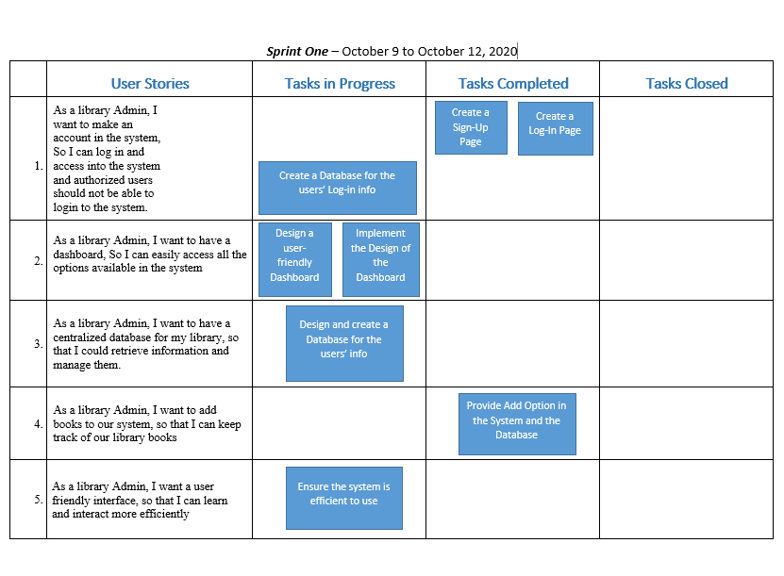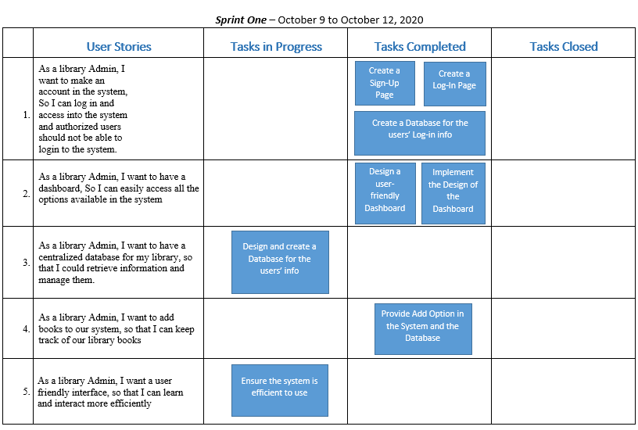

Day 1 of the Sprint

Day 2 of the Sprint

Burn Out Chart

|  |  |  |  |  |  |  |
| --- | --- | --- | --- | --- | --- | --- |
|  | **Day 0** | **Day 1** | **Day 2** | **Day 3** | **Day 4** | **Day 5** |
| **Estimated Effort** | 20 | 16 | 12 | 8 | 4 | 0 |
| **Actual Effort** | 20 | 6 | 6 | 4 | 2 | 0 |

|  |  |  |  |  |  |
| --- | --- | --- | --- | --- | --- |
| **Tasks** | **Hours** | **Day 1** | **Day 2** | **Day 3** | **Day 4** |
| Create a Sign-Up Page | 2 | 2 |  |  |  |
| Create a Log-In Page | 2 | 2 |  |  |  |
| Create a Database for the users' Log-in Info | 2 |  | 2 |  |  |
| Design a user-friendly Dashboard | 2 |  | 2 |  |  |
| Implement the design of the Dashboard | 2 |  | 2 |  |  |
| Ensure the System is efficient to use | 2 |  |  | 2 |  |
| Provide "Add Books" option in the System and in the Database | 4 | 2 |  | 2 |  |
| Design and create a Database for the users' info | 4 |  |  |  | 2 |
| **Total Hours:** | **20** | **6** | **6** | **4** | **2** |

After Masouma Tajik presented the increment, the Team’s work procedure and approach and the result, the Product Owner was pleased with the work of the Development Team. The Product Owner was entirely on track throughout the process of the first increment, therefore, she did not have any negative comments on the increment. She did have a few comments in terms of the theme and colors of the interface of the project, but other than that, the first increment was surprisingly successful. The Product Owner was pleased with majority of the work done by the Team. The meeting was a success and the Project Owner was satisfied with the first increment and gave a green light for the team to proceed with the second increment and make it ready for presentation on October 16, 2020.